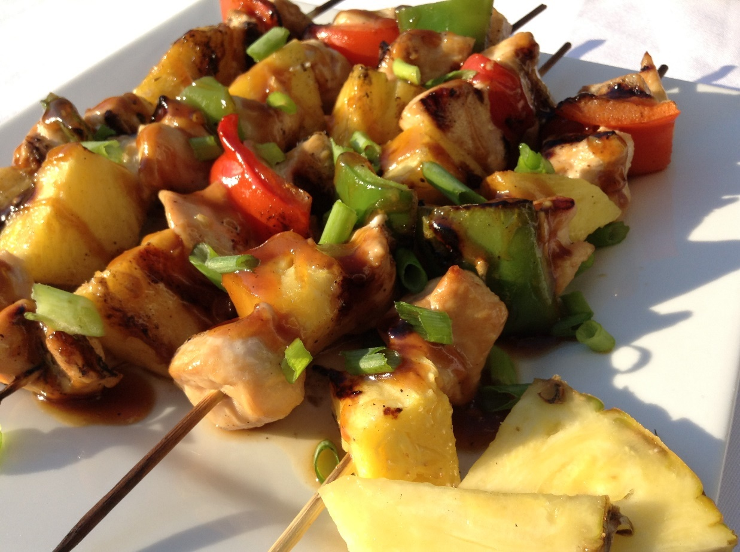
Grilled Teriyaki Chicken Skewers

When the days are warm and the house is too, it is nice to be able to cook outside. Grilled Teriyaki Chicken Skewers are pretty much a whole meal on a bamboo twig! Fresh pineapple grills up beautifully with the chicken and peppers. Teriyaki sauce drizzled over the whole works adds even more flavor. How good it is to be engulfed in summer!

The Recipe for Grilled Teriyaki Chicken Skewers:

3 large chicken breasts cut into 1 inch size chunks

Marinade and sauce:
2/3 cup soy sauce
2/3 cup pineapple juice
4 tbsp. vinegar
6 tbsp. vegetable oil
1/2 cup packed dark brown sugar
1 tsp powdered ginger (optional)
4 garlic cloves, minced
1 tsp salt
½ tsp pepper

Thicken with:
1 tbsp. cornstarch
3 tbsp. water (mixed together)

Also:
1 red pepper
1 green pepper
1/2 fresh pineapple

Method:
- Soak about 12 bamboo skewers in water while you prepare the chicken.
- Use a glass, liquid measuring cup to mix all the marinade ingredients.
- Pour half of the marinade over the chicken strips and stir it to coat the chicken. Set the other half aside.
- Place the marinated chicken in the fridge, covered, for at least a half an hour, stirring occasionally.
- Meanwhile chop the peppers and the pineapple into 1 inch size pieces.
- Thread the chicken, peppers and pineapple chunks onto the soaked skewers. Use two pineapple chunks and two pepper pieces on each skewer.
- Start and end with a chunk of marinated chicken. This helps everything to stay on the skewer better.
- Heat the BBQ to medium heat (about 350°) and lightly oil the grates.
- Place the prepared skewers on the hot grates and time them for 5 minutes on each side.
- Cook the remaining marinade ingredients in a small saucepan.
- Thicken the sauce with the cornstarch mixture when the marinade starts to boil.
- When the skewers have spent 10 minutes on the grill, open the lid and turn off the heat. The skewers can rest there for a few minutes while you finish the sauce.
- Place the skewers on a platter and drizzle part of the cooked sauce over them. Serve the rest of the sauce on the side to pour over rice or as a dipping sauce for the skewers.
- Garnish the Grilled Teriyaki Skewers with fresh sliced green onions for a wonderful gourmet touch.

Note:
I always say that everything tastes better when you eat it outside. Try make the most of the beautiful summer days and make it a special occasion every night by eating outdoors!

